Bluetooth LE controller
Friday, June 28, 2024
3:40 PM

Bluetooth Low Energy (LE) devices operate in the unlicensed 2.4 GHz ISM (Industrial Scientific Medical) band

----------------------------------------------------------- PHYSICAL LAYER ------------------------------------------------------------------------
The mandatory modulation scheme
1 - 1 Msym/s modulation -> The symbol rate is 1 Msym/s.
2 - 2 Msym/s modulation - > The symbol rate of 2 Msym/s.

The 1 Msym/s modulation supports two PHYs:
• LE 1M, with uncoded data at 1 Mb/s.
• LE Coded, with the Access Address, Coding Indicator, and TERM1 coded at 125 kb/s and the payload coded at either 125 kb/s or 500 kb/s.

The 2 Msym/s modulation supports a single PHY:
• LE 2M, with uncoded data at 2 Mb/s.

A Time Division Duplex (TDD) scheme is used on all PHYs.

The LE system operates in the 2.4 GHz ISM band at 2400 MHz to 2483.5 MHz. The LE system uses 40 RF channels with center frequencies at a 2 MHz spacing from 2402 MHz to 2480 MHz.

---------------------------------------------------- LINK LAYER --------------------------------------------------------------------------------------------------------

LINK LAYER STATES:
• Standby State
->The Link Layer in the Standby state does not transmit or receive any packets. The Standby state can be entered from any other state.
• Advertising State
->The Link Layer in the Advertising state will be transmitting advertising physical channel packets and possibly listening to and responding to responses triggered by these advertising physical channel packets. A device in the Advertising state is known as an advertiser. The Advertising state can be entered from the Standby state.
• Scanning State
->The Link Layer in the Scanning state will be listening for advertising physical channel packets from devices that are advertising. A device in the Scanning state is known as a scanner. The Scanning state can be entered from the Standby state.
• Initiating State
->The Link Layer in the Initiating state will be listening for advertising physical channel packets from a specific device(s) and responding to these packets to initiate a connection with another device. A device in the Initiating state is known as an initiator. The Initiating state can be entered from the Standby state.
• Connection State
->The Connection state can be entered either from the Initiating state or the Advertising state. A device in the Connection state is known as being in a connection.

Within the Connection state, two roles are defined:
• Central Role
• Peripheral Role
->When entered from the Initiating state, the Connection state shall be in the Central Role. When entered from the Advertising state, the Connection state shall be in the Peripheral Role
->The Link Layer in the Central Role will communicate with a device in the Peripheral Role and defines the timings of transmissions. The Link Layer in the Peripheral Role will communicate with a single device in the Central Role.

• Synchronization State
• Isochronous Broadcasting State

The Link Layer state machine allows only one state to be active at a time

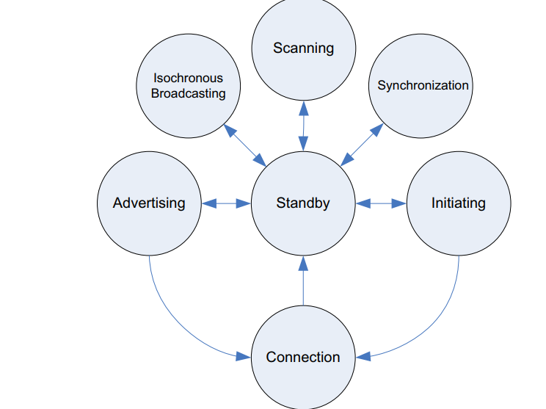
BIT ORDERING
The bit ordering when defining fields within the packet or Protocol Data Unit (PDU) in the Link Layer specification follows the little-endian format.
The following rules apply:
• The Least Significant Bit (LSB) corresponds to b0
• The LSB is the first bit sent over the air
• In illustrations, the LSB is shown on the left side

DEVICE ADDRESS:
https://developerhelp.microchip.com/xwiki/bin/view/applications/ble/introduction/bluetooth-architecture/bluetooth-controller-layer/bluetooth-link-layer/Device-Address/#:~:text=Bluetooth%C2%AE%20Low%2DEnergy%20Device%20Address,-The%20fundamental%20identifier&text=An%20additional%20address%20bit%20is,is%20specified%20by%20the%20host.

https://novelbits.io/bluetooth-address-privacy-ble/

Devices are identified using a device address and an address type; the address type indicates either a public device address or a random device address. A public device address and a random device address are both 48 bits in length.
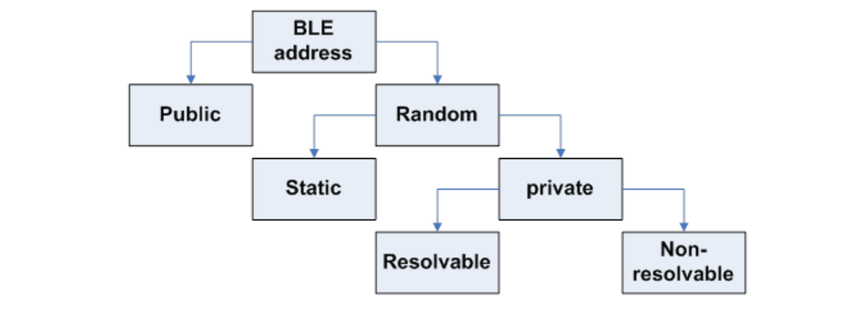
->Public device address
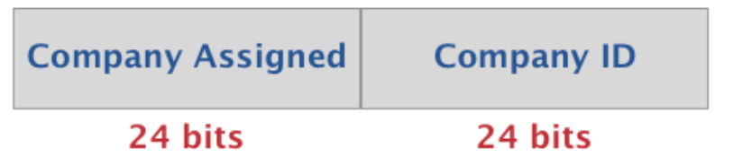
->Random device address
• Static address
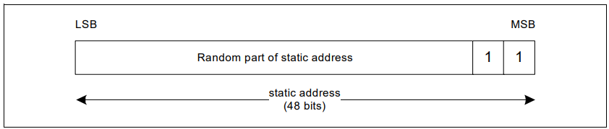
->A static address is a 48-bit randomly generated address and shall meet the following requirements:
• At least one bit of the random part of the address shall be 0
• At least one bit of the random part of the address shall be 1
->A device may choose to initialize its static address to a new value after each power cycle. A device shall not change its static address value once initialized until the device is power cycled.
• Private address
• Non-resolvable private address
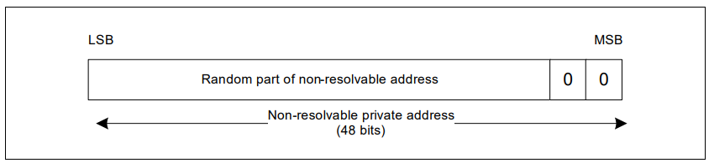
->To generate a non-resolvable address, the device shall generate a 48-bit address with the following requirements:
• At least one bit of the random part of the address shall be 1
• At least one bit of the random part of the address shall be 0
• The address shall not be equal to the public address

• Resolvable private address
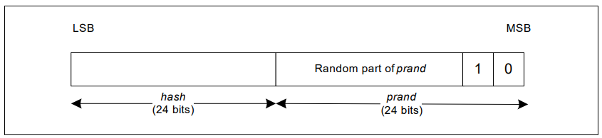
-> To generate a resolvable private address, the device must have either the Local Identity Resolving Key (IRK) or the Peer Identity Resolving Key (IRK).
The resolvable private address shall be generated with the IRK and a randomly generated 24-bit number.
The random number is known as prand and shall meet the following requirements:
• At least one bit of the random part of prand shall be 0
• At least one bit of the random part of prand shall be 1

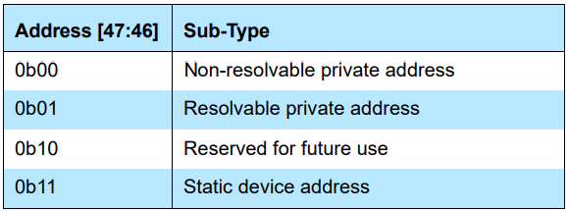

PACKET FORMAT FOR THE LE
LE UnCoded PHY's ( 1 M , 2 M)
LE Coded PHY's

1 - PACKET FORMAT FOR THE LE UNCODED PHYS
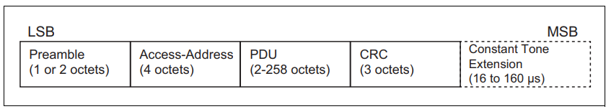

Preamble :
The preamble is a fixed sequence of alternating 0 and 1 bits. For packets transmitted on the LE 1M PHY, the preamble is 8 bits; for packets transmitted on the LE 2M PHY, the preamble is 16 bits.

Access-Address :
The Access Address for all other advertising physical channel packets shall be 0b10001110_10001001_10111110_11010110 (0x8E89BED6)

PDU:
When a packet is transmitted on either the primary or secondary advertising physical channel or the periodic physical channel, the PDU shall be the Advertising Physical Channel PDU
When a packet is transmitted on the data physical channel, the PDU shall be the Data Physical Channel PDU

CRC :::
The PDU is followed by a 24-bit CRC. It shall be calculated over the PDU.

2 - PACKET FORMAT FOR THE LE CODED PHYs
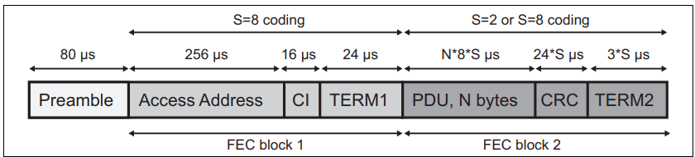
Each packet consists of the Preamble, FEC block 1, and FEC block 2.

-> The FEC block 1 consists of three fields: Access Address, Coding Indicator (CI), and TERM1. These shall use the S=8 coding scheme.
->The CI determines which coding scheme is used for FEC block 2.
->The FEC block 2 consists of three fields: PDU, CRC, and TERM2. These shall use either the S=2 or S=8 coding scheme.
Preamble ::
The Preamble is 80 symbols in length and consists of 10 repetitions of the symbol pattern '00111100' (in transmission order).

Coding Indicator:
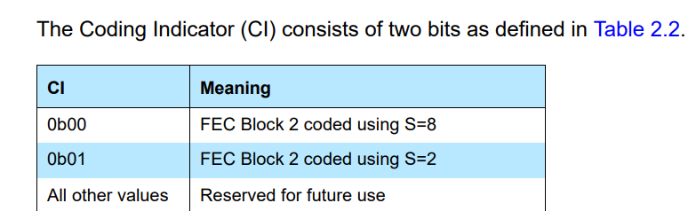

->There is a terminator at the end of each FEC block referred to as TERM1 and TERM2. Each terminator is 3 bits long and forms the termination sequence

Different PDU in LE
1 - ADVERTISING PHYSICAL CHANNEL PDU
The advertising physical channel PDU has a 16-bit header and a variable size payload.
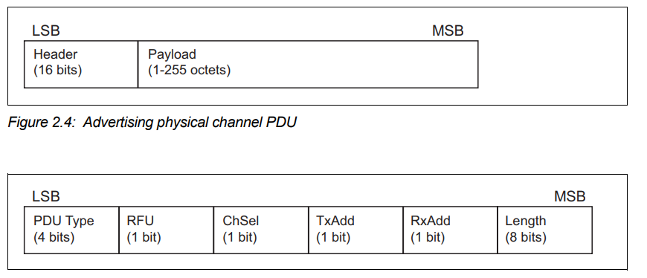

Pdu types that can be used ::
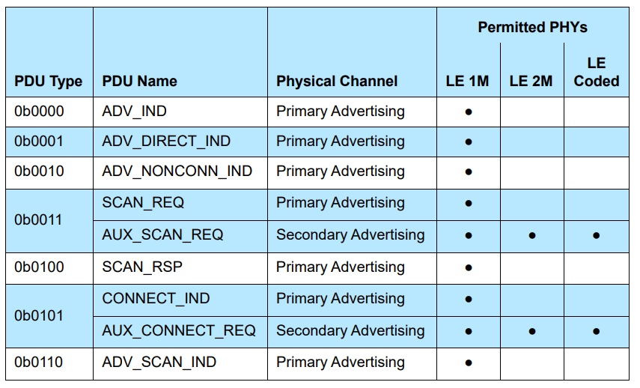
.The Length field of the advertising physical channel PDU header indicates the length of the payload in octets. The valid range of the Length field shall be 1 to 255 octets.

Advertising PDUs:
legacy advertising PDUs
• ADV_IND ->used in connectable and scannable undirected advertising events.
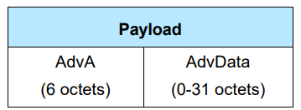
• ADV_DIRECT_IND -> PDU shall only be used in connectable directed advertising events.
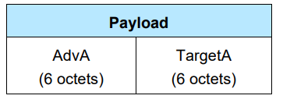
• ADV_NONCONN_IND ->PDU shall only be used in non-connectable and non-scannable undirected advertising events.
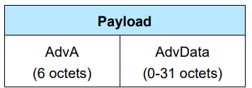
• ADV_SCAN_IND -> PDU shall only be used in scannable undirected advertising events.
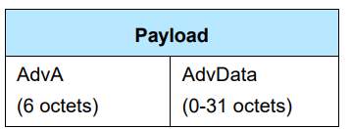
extended advertising PDUs
• ADV_EXT_IND
• AUX_ADV_IND
• AUX_SYNC_IND
• AUX_CHAIN_IND
• AUX_SYNC_SUBEVENT_IND
• AUX_SYNC_SUBEVENT_RSP

Scanning PDUs ::
• SCAN_REQ
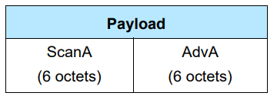
• SCAN_RSP
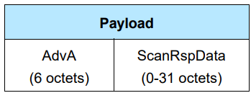
• AUX_SCAN_REQ
• AUX_SCAN_RSP

Initiating PDUs::
The CONNECT_IND and the AUX_CONNECT_REQ PDUs are sent by the Link Layer in the Initiating state and received by the Link Layer in the Advertising state.
• CONNECT_IND
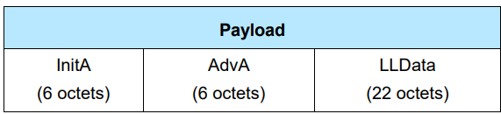

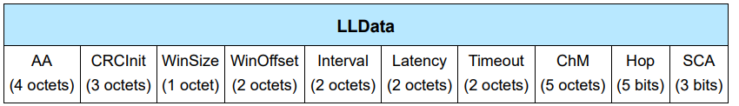
->AA
The AA field shall contain the ACL connection’s Access Address determined by the Link Layer.
->CRCInit
The CRCInit field shall contain the initialization value for the CRC calculation for the ACL connection.
->Window size & winoffset
The connInterval is used in the calculation of the maximum offset and size of the transmit window.
- The transmitWindowOffset and transmitWindowSize parameters are determined by the Link Layer.

The transmitWindowOffset shall be a multiple of 1.25 ms in the range 0 ms to connInterval. The transmitWindowSize shall be a multiple of 1.25 ms in the range 1.25 ms to the lesser of 10 ms and (connInterval - 1.25 ms)

• AUX_CONNECT_REQ
• AUX_CONNECT_RSP

DATA PHYSICAL CHANNEL PDU :;

The Data Physical Channel PDU has a 16 or 24 bit header, a variable size payload, and may include a Message Integrity Check (MIC) field

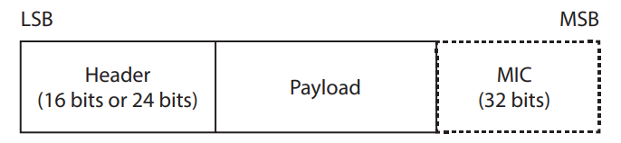

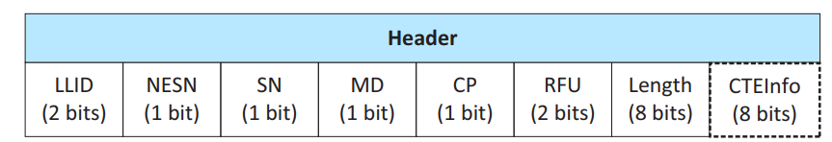

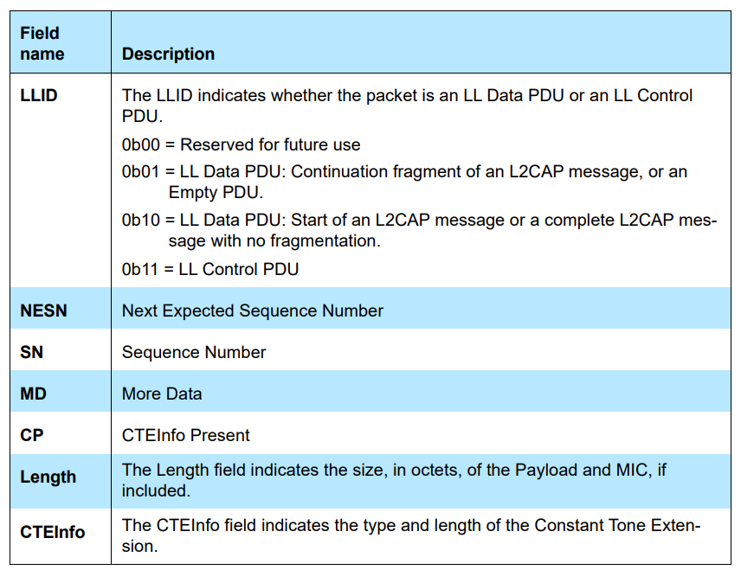

LL Data PDU
->An LL Data PDU is a Data Channel PDU that is used to send L2CAP data. The LLID field in the Header shall be set to either 0b01 or 0b10.

LL Control PDU
->An LL Control PDU is a Data Physical Channel PDU that is used to control the Link Layer connection.
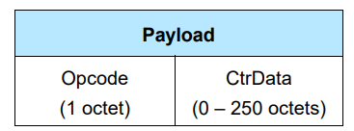

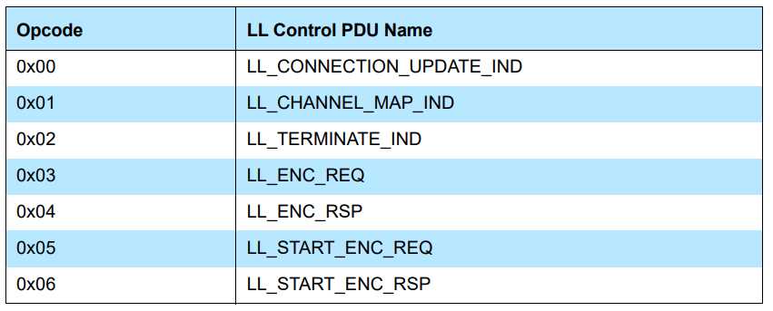

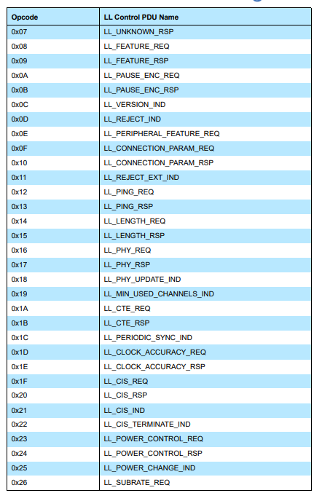

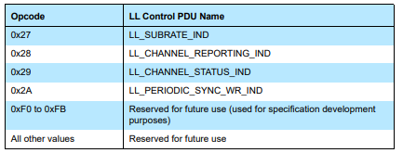

ISOCHRONOUS PHYSICAL CHANNEL PDU

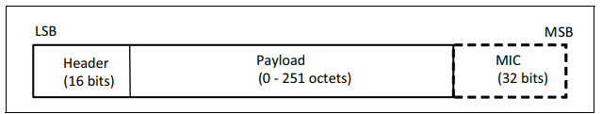

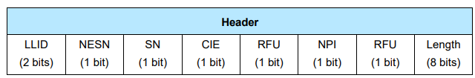

LE physical channels
Monday, July 1, 2024
3:15 PM

LE physical channels

In Bluetooth LE two devices uses a shared physical channel for communication. To achieve this, their transceivers need to be tuned to the same PHY frequency at the same time, and they need to be within a nominal range of each other.

LE uses a randomly generated Access Address to identify a physical channel between devices

1 - LE Piconet physical channel
->The LE piconet physical channel is used for communication between connected LE devices during normal operation
2 - Advertisement physical channel
->An LE advertising physical channel is used to set up connections between two devices or to communicate broadcast information between unconnected devices
3 - periodic physical channel
4 - LE Isochronous physical channel

There are two LE advertising physical channels: the primary advertising physical channel and the secondary advertising physical channel.

PHYSICAL LINKS
1 - Active physical link
->The physical link between a Central and a Peripheral is active if a default LE ACL logical transport exists between the devices.
-> Active physical links are each associated with a separate piconet physical channel, which in turn is identified by the randomly generated Access Address used in the Link Layer packet.
2 - Advertising physical link
->An advertising physical link between an advertising device and a scanning device used for periodic broadcasting of user data can exist for longer periods of time.
3 - Periodic physical link
->A periodic physical link between an advertising device and one or more scanning devices normally exists for a prolonged period of time.
4 - Isochronous physical links
->The isochronous physical link uses an isochronous physical channel and carries CIS and BIS logical transports.

LOGICAL TRANSPORT AND LOGICAL LINK

LOGICAL TRANSPORT :::
1 - LE asynchronous connection (ACL)
2 - LE Advertising Broadcast (ADVB)
3 - Connectionless Peripheral Broadcast(CPB)
4 - LE Periodic Advertising
->LE periodic advertising broadcast (PADVB)
->Periodic advertising with responses (PAwR)
5 - Connected Isochronous Stream(CIS)
6 - Connected Isochronous Group (CIG)
7 -Broadcast Isochronous Stream(BIS)
8 - Broadcast Isochronous Group (BIG)

LOGICAL LINK ::
1 - Control logical link (LE-C)
2 - User asynchronous logical link (LE-U)
3 - Advertising Broadcast Control logical link (ADVB-C)
4 - Advertising Broadcast User Data logical link (ADVB-U)
5 - Low Energy Stream (LE-S)
6 - Low Energy Framed (LE-F)
7 - Low Energy Broadcast Control (LEB-C)

L2CAP CHANNELS

Bluetooth Host
Tuesday, July 9, 2024
10:52 AM

ATT: - >Attribute protocol
The Attribute Protocol allows a device referred to as the server to expose a set of attributes and their associated values to a peer device referred to as the client. These attributes exposed by the server can be discovered, read, and written by a client, and can be indicated and notified by the server.

Attribute protocol defines 2 roles
1 - server
2 - client
.It allows a server to expose a set of attributes to a client that are accessible using the Attribute Protocol.

An attribute is a discrete value that has the following properties .
->Attribute Type
->attribute handle
->a set of permissions that are defined by each higher layer specification that utilizes the attribute; these permissions cannot be accessed using the Attribute Protocol

->Attribute Type
The attribute type specifies what the attribute represents.

->Attribute handle
The attribute handle uniquely identifies an attribute on a server, allowing a client to reference the attribute in read or write requests.
It allows a client to uniquely identify the attribute being notified or indicated.
Clients are able to discover the handles of the server’s attributes.
Permissions may be applied to an attribute to prevent applications from obtaining or altering an attribute’s value. An attribute may be defined by a higher layer specification to be readable or writable or both, and may have additional security requirements.

All Attribute Protocol requests are sent over an ATT bearer. There can be multiple ATT bearers established between two devices. Each ATT bearer uses a separate L2CAP channel and can have a different configuration.

1 - Attribute Type ::
A universally unique identifier (UUID) is used to identify every attribute type. A UUID is considered unique over all space and time.
The Attribute Protocol allows devices to identify attribute types using UUIDs regardless of the local handle used to identify them in a read or write request

All 32-bit Attribute UUIDs shall be converted to 128-bit UUIDs when the Attribute UUID is contained in an ATT PDU

2 - Attribute handle ::

An attribute handle is a 16-bit value that is assigned by each server to its own attributes to allow a client to reference those attributes. An attribute handle shall not be reused while an ATT bearer exists between a client and its server.
Attribute handles on any given server shall have unique, non-zero values. Attributes are ordered by attribute handle.
An attribute handle of value 0x0000 is reserved for future use. An attribute handle of value 0xFFFF is known as the maximum attribute handle.

3 - Attribute handle grouping
Grouping is defined by a specific attribute placed at the beginning of a range of other attributes that are grouped with that attribute, as defined by a higher layer specification. Clients can request the first and last handles associated with a group of attributes.

4 -Attribute value ::

An attribute value is an octet array that may be either fixed or variable length.
For example, it can be a one octet value, or a four octet integer, or a variable length string. An attribute may contain a value that is too large to transmit in a single PDU and can be sent using multiple PDUs. The values that are transmitted are opaque to the Attribute Protocol.

The encoding of these octet arrays is defined by the attribute type.
When transmitting attribute values in a request, a response, a notification or an indication, the attribute value length is not sent in any field of the majority of PDUs.

-> only one attribute value can be placed in a single request, response, notification or indication unless the attribute values have lengths known by both the server and client, as defined by the attribute type.

There are some PDUs where the length of attribute values is included as a field within the PDU and therefore the above implications do not apply to these PDUs.

5 - Attribute permissions
An attribute has a set of permission values associated with it. The permissions associated with an attribute specifies that it may be read and/or written. The permissions associated with the attribute specifies the security level required for read and/or write access, as well as notification and/or indication. The permissions of a given attribute are defined by a higher layer specification, and are not discoverable using the Attribute Protocol.

Attribute permissions are a combination of access permissions, encryption permissions, authentication permissions and authorization permissions.
The following access permissions are possible:
• Readable
• Writeable
• Readable and writable
The following encryption permissions are possible:
• Encryption required
• No encryption required
The following authentication permissions are possible:
• Authentication Required
• No Authentication Required
The following authorization permissions are possible:
• Authorization Required
• No Authorization Required

6 - Control-point attributes
Attributes that cannot be read, but can only be written, notified or indicated are called control-point attributes. These control-point attributes can be used by higher layers to enable device specific procedures.

7 - Exchanging MTU size
ATT_MTU is defined as the maximum size of any packet sent between a client and a server.
When using an L2CAP channel with a fixed CID, the client and server may optionally exchange the maximum size of a packet that can be received using the ATT_EXCHANGE_MTU_REQ and ATT_EXCHANGE_MTU_RSP PDUs.
A device that is acting as a server and client at the same time shall use the same value for Client Rx MTU and Server Rx MTU. When using an L2CAP channel with a dynamically allocated CID, the ATT_MTU shall be set to the L2CAP MTU size. The ATT_MTU value is a per ATT bearer value. A device with multiple ATT bearers may have a different ATT_MTU value for each ATT bearer.

8 - ATT bearers
An ATT bearer is a channel used to send Attribute Protocol PDUs. Each ATT bearer uses an L2CAP channel which shall be either a dynamically allocated channel or the LE Attribute Protocol fixed channel

A device may have any number of dynamically allocated channels and at most one fixed channel as ATT bearers to a peer device.

The L2CAP channel mode determines the behavior of Attribute Protocol on that ATT bearer. If the L2CAP channel mode is using Enhanced Credit Based Flow Control Mode, the ATT bearer is known as an Enhanced ATT bearer. Any ATT bearer that is not an Enhanced ATT bearer, using any other L2CAP channel mode, is known as an Unenhanced ATT bearer.

why LE audio is introduced as we have bluetooth classic

1. Power Efficiency
2.Improved Audio Quality
3. Scalability and Flexibility
4.

Questions in BLE
Thursday, July 25, 2024
7:01 PM

Eatt
Active and passive scan

